Installing cf-cli

# introduction

To CF CLI is the command line tool from where you can do admin operations on your PCF environment. To make use of it, you must install cf cli in your linux terminal.

The following guide will help you to install the latest version of cf cli.

# Get the CF CLI

You can download the CF packages for Linux\MacOS or Windows from here.

<https://github.com/cloudfoundry/cli/releases>

Else you can run following commands in your linux machine:

|  |
| --- |
| $ curl -L "https://cli.run.pivotal.io/stable?release=linux64-binary&source=github" | tar -zx |

It will download the latest version of cf cli in the extracted location.

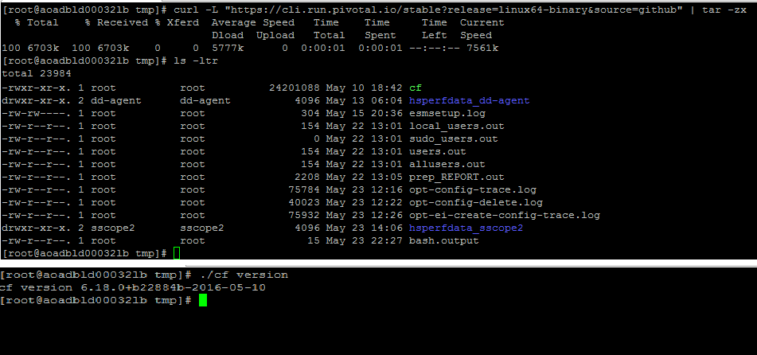

To check the version you have downloaded, you need to run the following command:

# ./cf –version.

But we do not want to run the command as a script rather we want it to be a service. This part is easy.

Copy the cf file to /usr/bin

# cp cf /usr/bin/

# Adding plugins

To extend capabilities of CF CLI you can add plugins to it. There are various plugins available for various tasks. For example, you can generate usage-report by adding usage-report plugin. Similarly, you can add diego-enabler plugin to help apps and spaces to move to diego or DEA according to the need.

To do so, the first step is to add the plugin repo. The command for that is:

|  |
| --- |
| [root@aoadbld00032lb tmp]# cf add-plugin-repo CF-Community http://plugins.cloudfoundry.org  FAILED  Plugin repo named "CF-Community" already exists, please use another name.  [root@aoadbld00032lb tmp]# |

We have already added the plugin repo, hence the message came. We are good here.

# To check all the available plugins in the repo

To CF CLI is the command line tool from where you can do admin operations on your PCF environment.

|  |
| --- |
| [root@aoadbld00032lb tmp]# cf repo-plugins  Getting plugins from all repositories ...  Repository: CF-Community  name version description  Firehose Plugin 0.9.0 This plugin allows you to connect to the firehose (CF admins only)  Scaleover 1.0.4 Roll traffic from one app to another by scaling over time  antifreeze 0.2.1 Detect if an app has unexpected ENV vars or services bound which are missing from the manifest  cf-willitconnect 1.1.0 Can CF connect to a thing?  Diego-Enabler 1.1.0 Enable/Disable Diego support for an app (CLI v6.13.0+)  Usage Report 1.3.0 Report on memory usage and application instances for orgs and spaces  fastpush 1.0.0 Fast, non-persistent, smart and incrementally updating of your application  doctor 1.0.2 doctor scans your deployed applications, routes and services for anomalies and reports any issues found. (CLI v6.7.0+)  Download Droplet 1.0.1 Download droplets to your local machine  manifest-generator 1.0.0 Help you to generate a manifest from 0 (CLI v6.7.0+)  kibana-me-logs 0.4.3 Launches the Kibana UI (from kibana-me-logs) for an application.  Cloud Deployment Plugin 1.0.1 This plugin allows you to manage application deployment details and manifests in a github repo (like spring cloud config server for deployments)  CLI-Recorder 1.0.2 Records and playbacks CLI commands.  Buildpack Management 1.0.0 Provides a declarative way to configure system buildpacks in a Cloud Foundry installation  Targets 1.1.0 Easily manage multiple CF targets  blue-green-deploy 1.0.4 Zero downtime deploys with smoke test support  Statistics 1.0.0 Display live metrics/statistics about an app  wildcard_plugin 1.0.0 Allows user to search and delete apps using wildcard(*)  CF App Stack Changer 1.1.0 Allows admins to list and update applications with outdated lucid64 stacks.  cf-download 1.0.0 Plugin for downloading your application contents after staging.  Copy Env 1.0.0 Expose remote VCAP_SERVICES on the client environment  Buildpack Usage 1.0.0 View all buildpacks used in the current CLI target context.  Test User 0.0.1 Create a user and assign all possible permissions, organisation and space are created if they do not already exist as well. If no organisation or space name are specified then the default value of 'development' is used  Brooklyn 0.1.1 Interact with Service Broker for Apache Brooklyn  autopilot 0.0.1 zero downtime deploy plugin for cf applications  Open 1.1.0 Open app url in browser  Console 1.0.0 Start a tmate session on an application container  Live Stats 1.0.0 Monitor CPU and Memory usage on an app via the browser.  [root@aoadbld00032lb tmp]# |

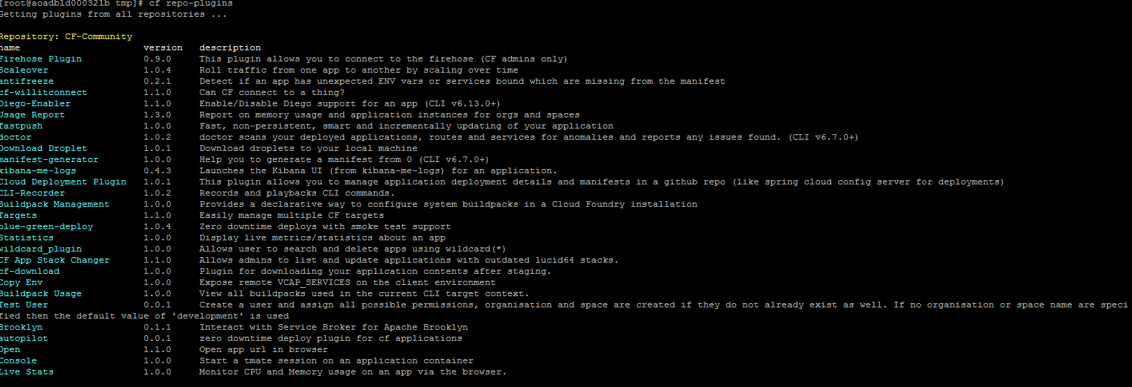

# Adding diego-enabler plugin

|  |
| --- |
| [root@aoadbld00032lb tmp]# cf install-plugin Diego-Enabler -r CF-Community  **Attention: Plugins are binaries written by potentially untrusted authors. Install and use plugins at your own risk.**  Do you want to install the plugin Diego-Enabler? (y or n)> yes  Looking up 'Diego-Enabler' from repository 'CF-Community'  12741304 bytes downloaded...  Installing plugin /tmp/ filename=diego-enabler_linux_amd64...  OK  Plugin Diego-Enabler v1.0.1 successfully installed.  [root@aoadbld00032lb tmp]# |

# ADDing usage-report plugin

|  |
| --- |
| [root@aoadbld00032lb tmp]# cf install-plugin "Usage Report" -r CF-Community  **Attention: Plugins are binaries written by potentially untrusted authors. Install and use plugins at your own risk.**  Do you want to install the plugin Usage Report? (y or n)> yes  Looking up 'Usage Report' from repository 'CF-Community'  8908816 bytes downloaded...  Installing plugin /tmp/usagereport-plugin...  OK  Plugin usage-report v1.3.0 successfully installed.  [root@aoadbld00032lb tmp]# |

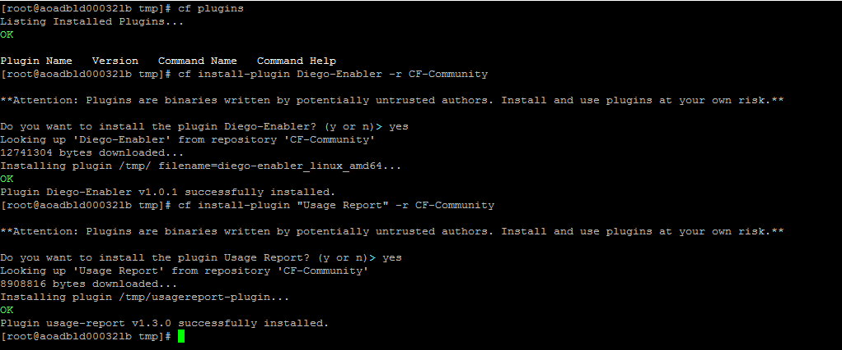

# CF Statisitcs

How about knowing the stats of an application? Here is the plugin called "Statistics".

* Install using:

#cf install-plugin "Statistics" -r CF-Community

* Target an org & space:

#cf target -o EnterpriseIntegration -s TibcoCloudDev

* Run against an application

#cf statistics HTTP-JMS-JDBC.application

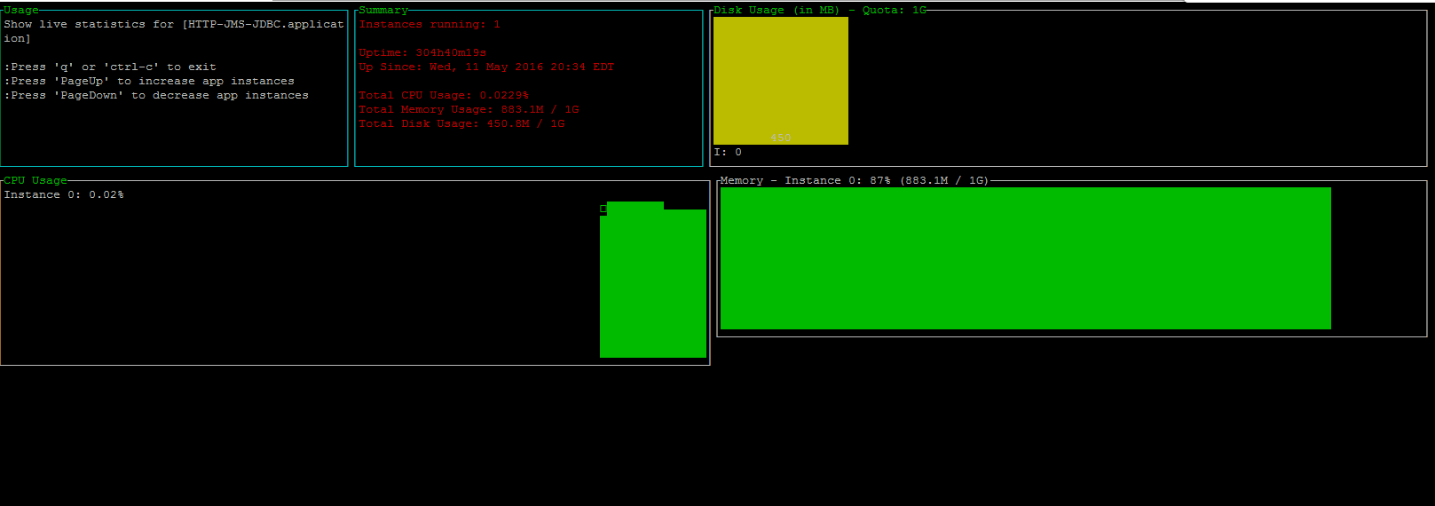

# CF kibana-me plugin

|  |
| --- |
| [root@aoadbld00032lb openplatform]# cf add-plugin-repo community http://plugins.cfapps.io/  OK  http://plugins.cfapps.io/list added as 'community'  [root@aoadbld00032lb openplatform]# cf install-plugin kibana-me-logs -r community  **Attention: Plugins are binaries written by potentially untrusted authors. Install and use plugins at your own risk.**  Do you want to install the plugin kibana-me-logs? (y or n)> yes  Looking up 'kibana-me-logs' from repository 'community'  8872680 bytes downloaded...  Installing plugin /tmp/ filename=cf-plugin-kibana-me-logs_linux_amd64...  OK  Plugin kibana-me-logs v0.4.3 successfully installed.  [root@aoadbld00032lb openplatform]# |

# CF targets plugin

**Plugin Name**: Targets

**Version**: 1.1.0

**Purpose**: Easily manage multiple CF targets

## Add the plugin:

#cf add-plugin-repo CF-Community http://plugins.cloudfoundry.org/

#cf install-plugin targets -r CF-Community

## Target &save the intended environment

Example:

#cf login --skip-ssl-validation -a <https://api.devcloudwest.inbcu.com>

Provide username and password and then execute following command:

*#cf save-target NAME*

#cf save-target devcloudwest

## check the targets

#cf targets

|  |
| --- |
| [root@aoaaplp00336 openplatform]# cf targets  cloudeast  cloudwest  devcloudwest (current, modified) |

Add more targets if you have.

## Point to the intended target

#cf set-target devcloudwest